Hello Gentlemen, new to this wonderful board as well as new to micro electrics. Started this Irrigation Controller about a two weeks ago, after finding Pete B’s U tube video on this project. Got all the parts and have started building by following Pete B’s video. Have a few part questions and am not very literal with the nomenclature.
- This 4.7uF 50V 20% Axial-Lead Electrolytic Capacitor goes on which end or pins on the 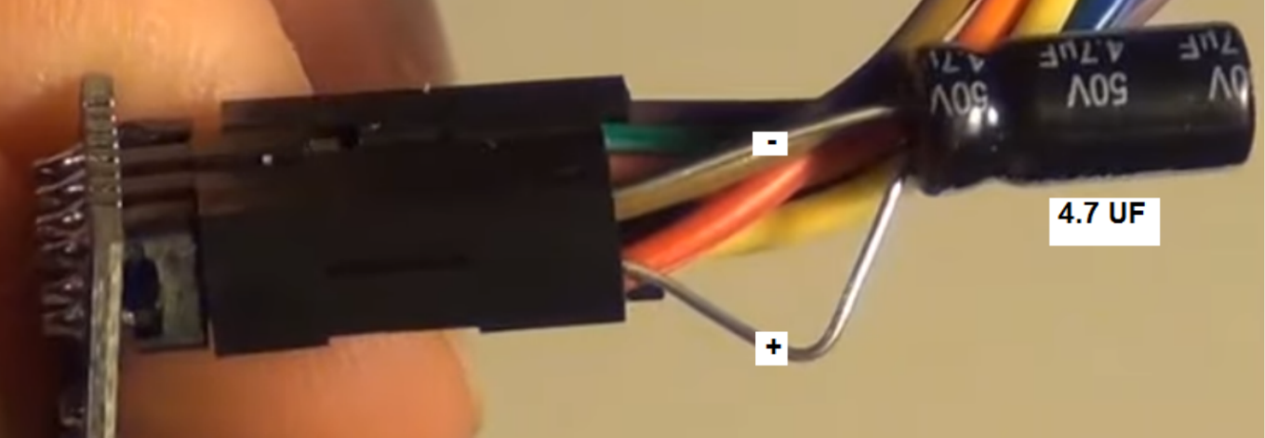
- Have a FT232RL FTDI USB 3.3V 5.5V to TTL Serial Adapter Module for Mini Port that is different than Pete’s.
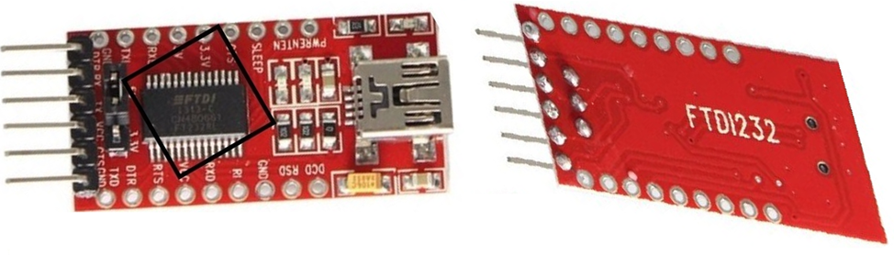
The Pins on the ftdi are different than on Pete’s board, in that I cannot find the info for the double GND on the Arduino Pro Mini.
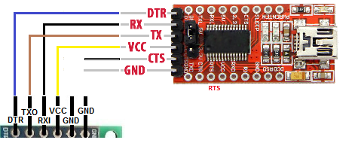
Any enlightenment of if this will work will be appreciated.
RJ Myers

